**Test Report**

1. **Authentication test (Integrated security test)**

**Importance :**

This is important for the security of the app and user accounts. In X-tag we save players data, rank them and track their performance.

But no one can change the data inside an user profile without playing the game.

**How was the test done:**

Done manually by testing these possibilities.

**What was tested ,Results and findings:**

* **Can user register with same email again**

No, but any error will not displayed

Time up msg should be displayed

* **Can user log in before user verification**
  + No
  + Verification mail goes to the provided mail
  + Works smoothly
* **What if user forgot the password**
  + Can go the forgot password option
* **What happens if the user enter the wrong password or email**
  + No error message.Fixed that
* **Can user log in with multi devices at the same time**
  + Yes can
  + **What happen if both try to enter the same match**
    - Can't create two players at the same time
    - Both or more will see the same screen
* **The limit of the sign-up quota**
  + Set sign up quota to 100 per hour currently
  + (from the same ip address)
* **Sign up with a valid email**
  + - Results: Waits until the verification is done.(no instruction message displayed)
* **Sign up with an invalid email**
  + - Results: error msg displayed
* **Did not refresh the register screen when logged in**
  + Fixed that issue

**2.Network compatibility testing**

**Importance :**

We tested X-tag app in the real world, network conditions can be different, Using This Test we monitored how the app performed across different network environments.

**What we tested:**

Time taken for Selecting gun, team and the match duration in the database.

Measured the time 25 times,

* Mobile 2G
* Mobile 3G
* Mobile 4G
* Wifi 4G network conditions.

**How was the test done:**

Added the following code and graphed the results.

int i = 0;

for (i = 0; i < 25; i++) {

sleep1();

Stopwatch stopwatch = new Stopwatch()..start();

try {

User user = _auth.currentUser;

//database update

} catch (e) {

print(e.toString());

}

print('change value $i ${stopwatch.elapsed}');

}

**Results and findings:**

Time taken for Selecting gun, team and the match duration in the database for 25 attempts are as follows. Time is in seconds.

|  |  |  |  |  |
| --- | --- | --- | --- | --- |
| **Attempt** | **Wi-fi 4G** | **Mobile 4G** | **Mobile 3G** | **Mobile 2G** |
| **1** | 0.315404 | 0.320198 | 1.648746 | 4.293811 |
| **2** | 0.368186 | 0.313119 | 0.880405 | 1.175932 |
| **3** | 0.309419 | 0.328745 | 0.61963 | 0.60251 |
| **4** | 0.364689 | 0.314767 | 0.628514 | 0.518855 |
| **5** | 0.239885 | 0.240182 | 0.680837 | 1.031038 |
| **6** | 0.284624 | 0.308419 | 0.869218 | 2.050813 |
| **7** | 0.232842 | 0.322398 | 0.74932 | 0.354271 |
| **8** | 0.306113 | 0.314951 | 0.998595 | 0.565656 |
| **9** | 0.22375 | 0.25114 | 0.658921 | 0.376293 |
| **10** | 0.224903 | 0.222431 | 0.22263 | 6.139117 |
| **11** | 0.216957 | 0.251344 | 0.220462 | 4.044457 |
| **12** | 0.286734 | 0.320239 | 0.228428 | 0.877275 |
| **13** | 0.299806 | 1.063794 | 0.23024 | 1.462894 |
| **14** | 0.287429 | 0.668062 | 0.226045 | 1.699495 |
| **15** | 0.298734 | 0.240035 | 0.222595 | 0.596887 |
| **16** | 0.291522 | 0.242156 | 0.227038 | 0.400895 |
| **17** | 0.228106 | 0.237089 | 0.226708 | 2.820729 |
| **18** | 0.225475 | 0.245969 | 0.227591 | 0.560463 |
| **19** | 0.277104 | 0.293077 | 0.240537 | 0.451406 |
| **20** | 0.222439 | 0.298764 | 0.226879 | 0.400895 |
| **21** | 0.216372 | 0.324562 | 0.231915 | 0.560463 |
| **22** | 0.227422 | 0.392342 | 0.233594 | 0.451406 |
| **23** | 0.298734 | 0.283477 | 0.21868 | 0.400895 |
| **24** | 0.228106 | 0.322398 | 0.217272 | 1.175932 |
| **25** | 0.226213 | 0.222431 | 0.248694 | 0.451406 |

**Average time**

|  |  |
| --- | --- |
| **Network Condition** | **Average time taken** |
| **Wifi 4G** | **0.268039 s** |
| **Mobile 4G** | **0.333684 s** |
| **Mobile 3G** | **0.455340 s** |
| **Mobile 2G** | **1.228552 s** |

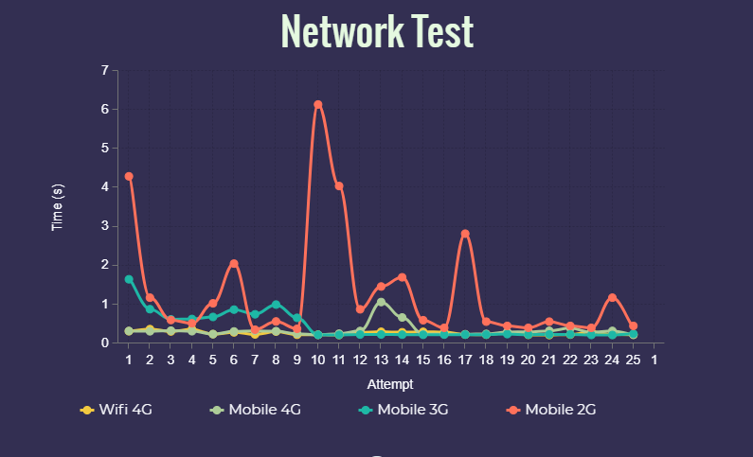

**3. Data Mapping testing**

**Importance?**

Database testing helps in protecting the most important component of the app which is data. The correct Structure is very import for the whole process of gaming

**What was tested?**

1.When authentication happens a player document is created.

2.when the match happening is match document is created with unique id

i). when the players are adding, nested players coll. Is created with the userid as a doc. ID

3.When match is finished is nested played match is created updated field

4.Is match database is deleted after upload the data

**How was the test done:**

Manually by using application UI when we know the database integration.

**Results and findings:**

Database structure is created perfectly.

But there is a possibility,

To lose match data when they are deleted from the ‘match’ collection.

Therefore those data were uploaded when the match was over.

And deleting a whole collection by a user is not recommended by the fire store.

How ever since we delete only the doc . under the collection.

**4. Stored Procedures(Black box testing)**

Perform an operation from the front end (UI) of the application and check for the execution of the stored procedure and its results.

**Importance?**

We should minimize the read and write results in to the database

Otherwise it can be expensive. And also the app will work efficiently.

**What was tested?**

* How many times read and write the data to the back ends.
* Are they correct values?

**How was the test done?**

Using the ui and the Cloud firestore usage interface.

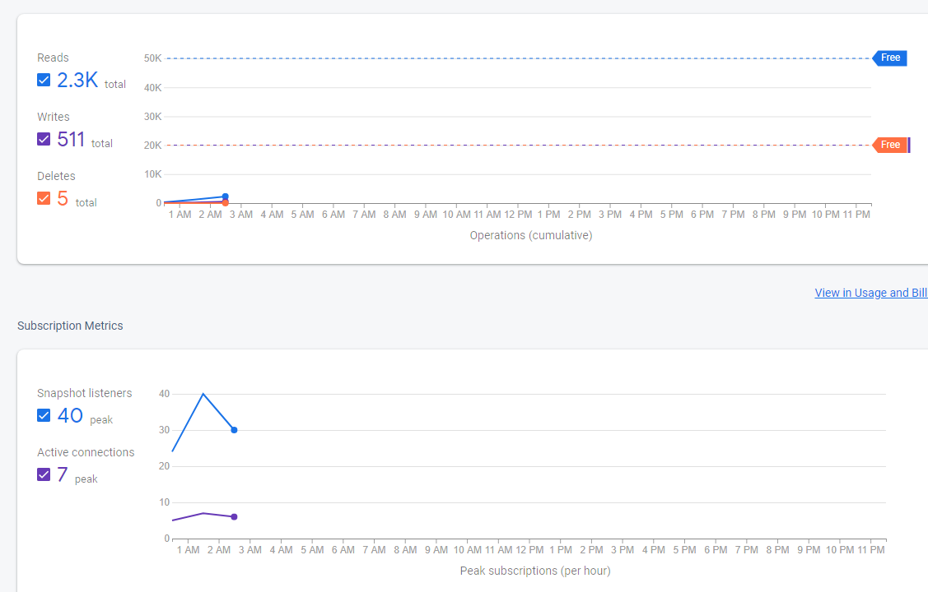

|  |  |  |  |
| --- | --- | --- | --- |
|  | read | writes | deletes |
| When creating a game | 0 | 5 | 0 |
| Selecting the game setting  (Team, gun ,duration) | 2 | 3 | 0 |
| Someone joining | 7 | 10 | 0 |
| Start the battle | 6 | 1 | 0 |
| When get shot | 14 | 7 | 0 |
| When go to the home page | 0 | 8 | 0  1 |

**Results and findings:**

* Found that Some local data did not initialize.
* Found some data set as null because of that
  + Therefore when we get hit,first updated local variables and then those local variables are uploaded to the database.
* Therefore when we increase the database values, we don't have to read and write.

**5. Device compatibility testing**

**Importance :**

Users will use different types of devices to run this app.It is important to test Our app in different devices.

X-tag was tested across various mobile devices for confirming its compatibility.

**What was tested:**

* How does the app works with devices with different API levels
* Performance on each device
* Accessibility

**How the test was done:**

For this Robo test facility from Firebase Test lab was used. It automatically explores our app on multiple devices to find defects and report any crashes that occur.

**Results and findings:**

|  |  |  |  |  |  |
| --- | --- | --- | --- | --- | --- |
| Device | API level | Performance | | Accessibility issues | Link to results |
| Time to initial display | Time to full display |
| Nexus 6P | 27 | 2s 311ms | 11s 648ms | Content labeling  Low contrast | <https://console.firebase.google.com/u/0/project/xtag-demo/testlab/histories/bh.cff1cff84a6229f8/matrices/9097277482848772899/executions/bs.df6b20a5ecbd8f7f/performance> |
| Nexus 5 | 23 | 1s 417ms | 7s 781ms |  | <https://console.firebase.google.com/u/0/project/xtag-demo/testlab/histories/bh.cff1cff84a6229f8/matrices/9097277482848772899/executions/bs.8b5197996df320f7/performance> |
| Pixel 2 | 30 | 2s 626ms | 13s 923ms |  | <https://console.firebase.google.com/u/0/project/xtag-demo/testlab/histories/bh.cff1cff84a6229f8/matrices/9097277482848772899/executions/bs.b108e0fbc4308b77/performance> |
| Low  resolution MDPI phone | 30 | 2s 366ms | 15s 979ms |  | <https://console.firebase.google.com/u/0/project/xtag-demo/testlab/histories/bh.cff1cff84a6229f8/matrices/9097277482848772899/executions/bs.a7f350076ebd7fb3/performance> |
| Nexus 6 | 25 | 1s 431ms | 7s 287ms | Content labeling  Low contrast | <https://console.firebase.google.com/u/0/project/xtag-demo/testlab/histories/bh.cff1cff84a6229f8/matrices/7091273565002506262/executions/bs.9bb48fe2fd1237a4/performance> |
| Nexus7 clone | 26 | 1s 287ms | 0 |  | <https://console.firebase.google.com/u/0/project/xtag-demo/testlab/histories/bh.cff1cff84a6229f8/matrices/9097277482848772899/executions/bs.145b51e5107e5168/performance> |
| Nexus 5X | 26 | 1s 304ms | 0 |  | <https://console.firebase.google.com/u/0/project/xtag-demo/testlab/histories/bh.cff1cff84a6229f8/matrices/9097277482848772899/executions/bs.c2253e72294b2358/performance> |